General Education Students MAXSCHOLAR

Using MaxScholar as a reading intervention program
improves literacy rate in different schools.
Background of Studies
It is well-known that students who are not reading by 3rd grade have a greater chance of lagging behind their peers. As they move up in grade level, the gap becomes wider. Despite many efforts at improving the reading skills of these students, there has been no significant improvement in 4th grade reading scores across the country as reported by the National Assessment of Educational Progress. (NAEP)

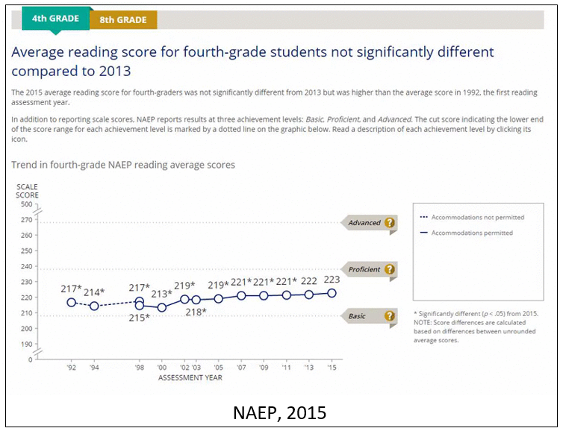

In attempting to analyze the reasons behind the failure of improvement, one should look at the work of Dr. Joseph Torgeson, Florida State University.

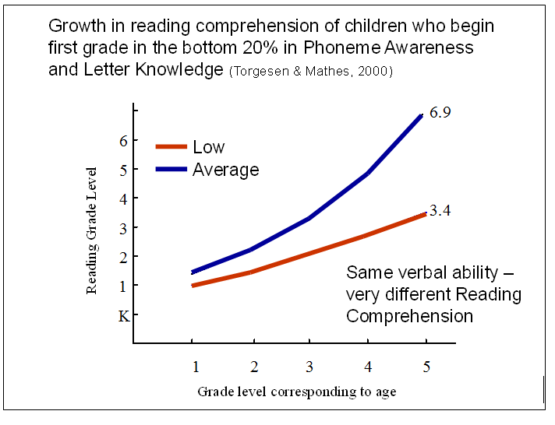

General Education Students MAXSCHOLAR

His research suggests that those students who start 1st grade without an adequate base of phonics and phonemic awareness never catch up to their peers. This problem is extremely prevalent in the lower socio-economic students, especially those who are English Language Learners and do not speak English at home.

One area of potential problem in most reading programs used in schools is that they lack a strong phonics component, meaning the “average” student does not receive an adequate foundation in phonics.

History of MaxScholar
The MaxScholar Reading Intervention Program is based on the observations that students who are behind in reading, no matter what the cause, will learn the best with programs that are explicit, systematic, and multi-sensory. Students must also be provided extensive drill and practice. MaxScholar is an Orton-Gillingham Phonics program, in electronic format, which meets those standards.

Case studies
In the following pages, a number of case studies conducted in different schools can be found:

Study 1- PS 6 West Farms School
The Study
Based on the hypothesis that many Elementary School students who are significantly behind in their reading skills will benefit most from a phonics/phonemic awareness program that is implemented with fidelity, PS 6 (Bronx) undertook a one academic year study to see if a phonics-based program in electronic format worked better than what had previously been used in the school.
The Fountas & Pinnell Benchmark Assessment Systems are accurate and reliable tools to identify the instructional and independent reading levels of all students and document student progress. This school uses The Fountas & Pinnell Assessments to monitor their students throughout the academic year. The students included in this study were all in the second grade in general education classes. None of them had IEPs or were on RTI programs.
78 students in four classroom groups participated in this study. The students worked on their program for 60 minutes three times each week for the entire school year. The results of the students were provided in June 2016.

Results
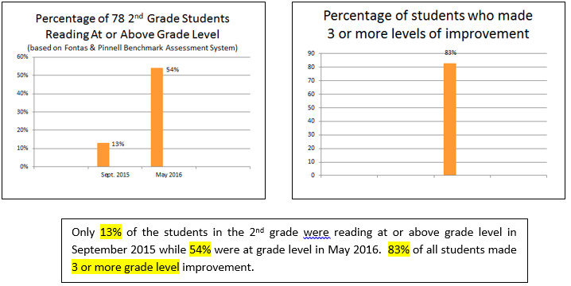

Comments
Low performing Elementary School students can reach grade level or at least show significant academic improvement using an Orton-Gillingham approach in an electronic format with frequent lessons.

State:
New York

County:
Bronx

School:
PS 6
West Farms School

Grades Served
PK, 1, 2, 3, 4, 5, SE

Race & Ethnicity:
Hispanic 70%
Black 27%
Asian 1%
White 0%

ELL’s 12%
Students chronically
Absent 45%

Minority Rate:
100%

Free or Reduced
Price Lunch:
96%

Entire school
performance on
State ELA testing:
11% met standards

Study Inclusion
Requirements:
78 students in 2nd
grade, all of whom
were below grade
level in F & P
assessments at the
beginning of the academic
year

Study 2- PS 75 Emily Dickinson School
The Study
PS 75 (Manhattan) undertook a one academic year study using a phonics-based program in electronic format for students in K through 5th grade. Students at this school traditionally have not performed will on State ELA testing. In addition, most of the students started the school year not reading at grade level. Of the 441 students who participated in the study, 61% were considered General Education students, while 39% were Special Needs (IEP, ELL, or IEP/ELL). The program was implemented in all grades by teachers who received extensive Professional Development in the use of the program. The students worked on their program for 60 minutes daily for the entire school year.

The Developmental Reading Assessment (DRA) is an individually administered assessment of a child’s reading capabilities. The DRA test is traditionally administered on a semi-annual basis. The test measures nine categories of reading behavior and six types of errors. This was the basis of evaluation.

Results
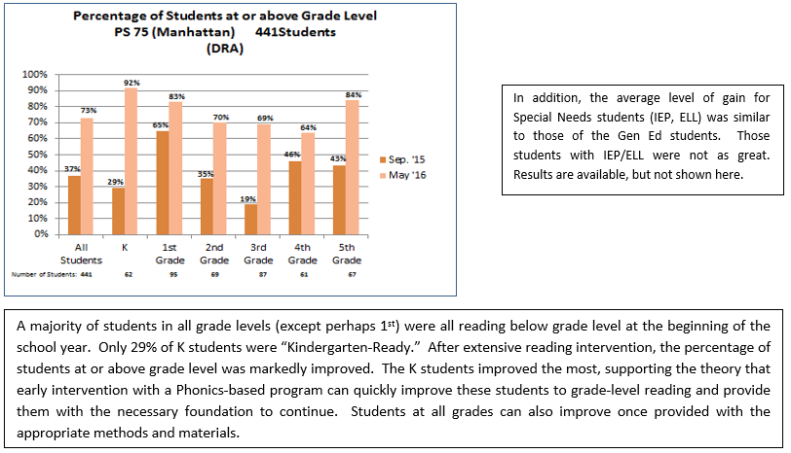

Comments
Elementary School students can reach grade level or at least show significant academic improvement using an Orton-Gillingham approach. This type of program can help many students if it is implemented properly.

State:
New York

County:
Manhattan

School:
PS 75
Emily Dickinson School

Grades Served
K, 1, 2, 3, 4, 5, SE

Race & Ethnicity:
Hispanic 53%
Black 25%
Asian 3%
White 17%

ELL’s 14%
Special Needs 28%

Free or Reduced
Price Lunch:
63%

Entire school
performance on
NY State ELA testing:
32% met standards

Study Inclusion
Requirements:
441 students in
K through 5th grade

Study 3- PS 100 Glen Morris School
The Study
PS 100 (Queens) undertook a one academic year study using a phonics-based program in electronic format for 850 students in K through 5th grade. Students at this school traditionally have not performed will on State ELA testing. In addition, most of the students started the school year not reading at grade level. The program was implemented in all grades by teachers who received extensive Professional Development in the use of the program. The students worked on their program for 60 minutes daily for the entire school year.

The Fountas & Pinnell Benchmark Assessment Systems are accurate and reliable tools to identify the instructional and independent reading levels of all students and document student progress. This school uses The Fountas & Pinnell Assessments to monitor their students throughout the academic year.

Results
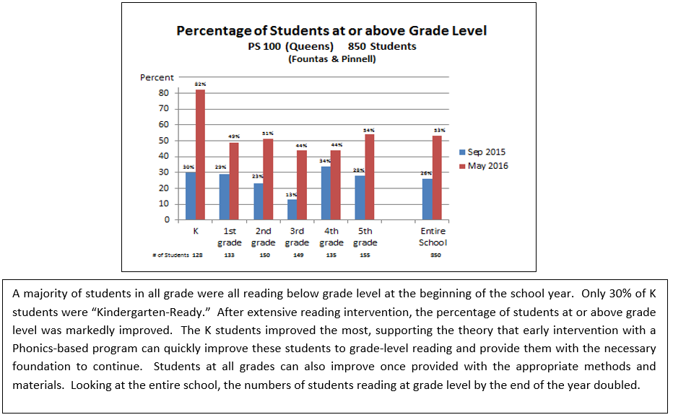

Comments
Elementary School students can reach grade level or at least show significant academic improvement using an Orton-Gillingham approach. This type of program can help many students if it is implemented properly.

State:
New York

County:
Queens

School:
PS 100
Glen Morris School

Grades Served
preK, K, 1, 2, 3, 4, 5, SE

Race & Ethnicity:
Hispanic 19%
Black 7%
Asian 49%
White 4%

ELL’s 8%
Special Needs 22%

Free or Reduced
Price Lunch:
79%

Entire school
performance on
NY State ELA testing:
35% met standards

Study Inclusion
Requirements:
441 students in
K through 5th grade

Study 4- PS 25 Eubie Blake School
The Study
Based on the hypothesis that many Elementary School students who are significantly behind in their reading skills will benefit most from a phonics/phonemic awareness program that is implemented with fidelity, PS 25 (Brooklyn) undertook a one academic year study to see if a phonics-based program in electronic format for students in Pre-K through 5th grade worked better than what had previously been used in the school. 114 students in 11 classroom groups participated in this study. The students worked on their program for 60 minutes daily for the entire school year. The results of the students were provided in June 2016.

The Fountas & Pinnell Benchmark Assessment Systems are accurate and reliable tools to identify the instructional and independent reading levels of all students and document student progress. This school uses The Fountas & Pinnell Assessments to monitor their students throughout the academic year.

Results
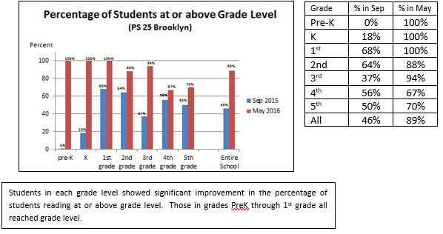

Comments
Elementary School students can reach grade level or at least show significant academic improvement using an Orton-Gillingham approach in an electronic format. The younger students all reached grade level suggesting that early intervention can make significant differences in these students.
State:
New York

County:
Brooklyn

School:
PS 25
Eubie Blake School

Grades Served
PK, 1, 2, 3, 4, 5, SE

Race & Ethnicity:
Hispanic 24%
Black 71%
Asian 2%
White 1%

ELL’s 10%
Students chronically
Absent 39%

Minority Rate:
100%

Free or Reduced
Price Lunch:
98%

Entire school
performance on
NY State ELA testing:
11% met standards

Study Inclusion
Requirements:
114 students in
Pre-K through
5th grade

Study 5- PS 163 Alfred E Smith School
The Study
Many Elementary School students who are significantly behind in their reading skills will benefit most from a phonics/phonemic awareness program that is implemented with fidelity. PS 163 (Manhattan) undertook a one academic year study using a phonics-based program in electronic format for students in K through 2nd grade whom the faculty felt needed special attention. 15 students in 7 classroom groups participated in this study. The students worked on their program for 60 minutes twice weekly before school for the entire school year.

The Fountas & Pinnell Benchmark Assessment Systems are accurate and reliable tools to identify the instructional and independent reading levels of all students and document student progress. This school uses The Fountas & Pinnell Assessments to monitor their students throughout the academic year.

Results
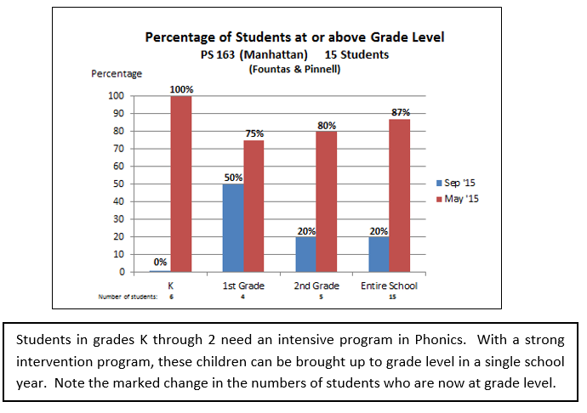

Comments
Elementary School students can reach grade level or at least show significant academic improvement using an Orton-Gillingham approach. This type of program can help many students if it is implemented properly.

State:
New York

County:
Manhattan

School:
PS 163
Alfred E Smith School

Grades Served
PK, K, 1, 2, 3, 4, 5, SE

Race & Ethnicity:
Hispanic 46%
Black 17%
Asian 6%
White 27%

ELL’s 7%
Special Needs 39%

Free or Reduced
Price Lunch:
56%

Entire school
performance on
NY State ELA testing:
51% met standards

Study Inclusion
Requirements:
15 students in
K through 2nd grade

Study 6- North Miami Middle School
The Study
Based on the hypothesis that many Middle School students who are significantly behind in their reading skills will benefit most from a phonics/phonemic awareness program that is implemented with fidelity, North Miami Middle School undertook a one academic year study to compare whether a phonics-based program worked better than a more typical reading program. Both programs were in electronic format.

The Florida Standards in Mathematics and English Language Arts (ELA) were approved by the Florida State Board of Education in February 2014 and were implemented in grades K–12 in the 2014–2015 school year. All Florida schools teach the Florida Standards, and students are assessed through the computer-based statewide Florida Standards Assessments (FSA) each year. The students in this study were all in Level 1 (Inadequate) or Level 2 (Below Satisfactory) in ELA on the assessment administered in 2015. The FSA defines “Learning Gains” for each Level and Grade.

136 students in two evenly divided groups participated in the study. 68 students used the iReady program and 68 the MaxScholar program. The students worked on their program for 50 minutes each day for the entire school year. The results of the students were provided only as the total number of students in each group that made learning gains.

Results
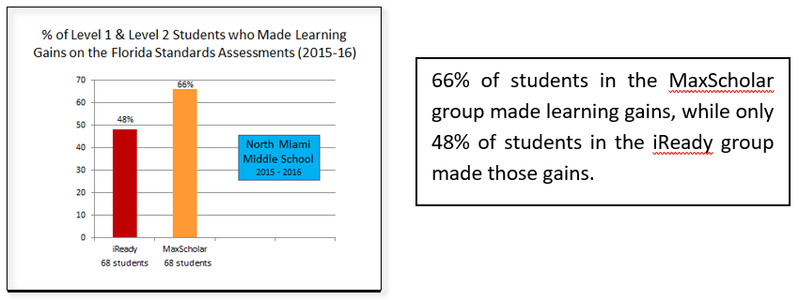

Comments
Low performing Middle School students can make more improvement with the use of a phonics-based reading intervention program with teachers who have been educated in how to use these methods and materials than with a more “conventional” reading program without a strong phonics component.

State:
Florida

County:
Miami-Dade

District:
Miami-Dade County
Public Schools

School:
North Miami
Middle School

Grades Served
6, 7, 8

Race & Ethnicity:
Hispanic 10%
Black 88%
Asian 0.4%
White 0.2%

Minority Rate:
100%

Free or Reduced
Price Lunch:
96%

Study Inclusion
Requirements:
136 students in 7th
grade, all of whom
had scored Level 1
or Level 2 in reading
on state achieve-
ment tests

Study 7- IS 51 Edwin Markham Intermediate School
The Study
Based on the hypothesis that many Middle School (Intermediate) students who are significantly behind in their reading skills will benefit most from a reading intervention program that integrates the research-based strategies of selective highlighting, vocabulary, outlining, summarization, open-ended responses, and reading comprehension that is implemented with fidelity. IS 51 (Staten Island) undertook a one academic year study to see if such a reading intervention program, available in electronic format, would make a difference in a group of 6th and 7th grade students. 442 6th grade students in 7 classroom groups and 26 7th grade students in 2 groups participated in this study. (Scores from testing in September 2015 and May 2016 for only 332 of the 6th graders were available. Those students became the basis for this study.) Of importance is the fact that 48% of the 6th grade students were classified as having disabilities, and 100% of the 7th graders had disabilities. It was not specified the types of disabilities. The students worked on their program for 60 minutes three times weekly for the entire school year. There were extrinsic rewards associated with this school. The results of the students were provided for analysis in June 2016.

Degrees of Reading Power (DRP) is an assessment test that evaluates reading comprehension. Syntax, semantics, and other basic linguistic skills are addressed. This assessment vehicle is frequently used in Middle Schools.

Results
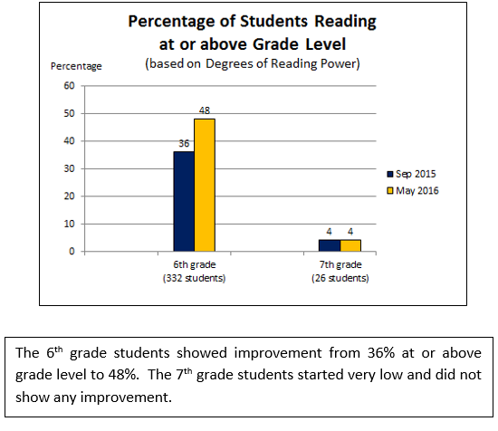

Comments
The 6th grade students at this school showed some improvement in their reading comprehension ability, but the 7th grade students did not budge. There was an unusually large percentage of students with disabilities (not better defined) of 46% of 6th graders and 100% of 7th graders. Perhaps those students who did not show improvement should have started with the Phonics program to build a stronger foundation in reading skills, something they never mastered in the lower grades.

State:
New York

County:
Staten Island

School:
IS 51
Edwin Markham
Intermediate School

Grades Served
6, 7, 8, SE

Race & Ethnicity:
Hispanic 46%
Black 22%
Asian 6%
White 25%

Students chronically
Absent 25%

Minority Rate:
75%

Free or Reduced
Price Lunch:
71%

Entire school
performance on
NY State ELA testing:
23% met standards

Study Inclusion
Requirements:
442 6th grade
students & 26
7th grade students

